Chapter 1 Introduction

In 21st century there is full of technological development and very hard to survive without using any technology. Computers, laptops and mobiles have become the part of our life for retrieve all kind of information. It is very difficult to survive for any business organization without using technology. Whole world is depending upon technology and used to share information. Due to the technology people used to buy a product through online. Nowadays, people are being lazy to cook food so they ordered the fast food through online and they delivered the food in their places. So people are addicted in this system.

So here I am proposing Online Food ordering System which is the processing order the food for customer. This system represents menu with all available options in easy way. Customer can choose one or more items and can confirm the order, if they want buy more then there is home button, they can easily buy more items from there. If the order is confirmed, you can cancel if you want but there is only limited time over there.

I just valued the learning about the JavaScript, HTML programming languages as well as seeing how dynamic they are in we designing. I have used JavaScript, HTML5, CSS, MySQL, bootstrap for this project.

* 1. Background of the system

Due to the technologies life has been easier now compare to pervious life. So people do not want to stay in queue for food. Nowadays, everyone is involving in the fast food and I also do not like to wait for my food in long queue. Its main aims are to provide the flexibility and usability and user satisfied. And also used the latest technology for this system.

So, in this project Customer can directly login if they have already their username and password no need to register again otherwise they must have to register. Customer can see the food which want to order and also can buy again if they want to buy any food. No need to wait long and your food on time. its user interface design is very well and can interact easily. And this project could make good benefit.

* 1. Overview of the system

Online Food Ordering system is a web based application whose language is PHP core. Its main aims are to deliver the food in given time. Technology makes our life easier and makes the customer satisfy. Customers can able to see the menus and can confirm the food order.

Customer can login the system and also can register to the system. Once the user logged in, customer can see the list of the food and can see the details of the food too. The details of food which is ordered by the customers are displayed in the dashboard in the admin panel and the customers can add the quantity and the price will be shown in there last. System is very user-friendly with functions by consideration to the system as much as can.

This system need internet to connect and to order the food. Having Knowledge of the internet can easy to use this system. It is very easy to use this system for anyone and great satisfaction by this system.

* 1. Description of the project

Features of the system:

There are many features and functions to meet the goals with to satisfy the customers. Some of the features are given below:

* User can get registered the system and can login to use the system.
* User can view any food they want; it means they have their own personal dashboard.
* User can get the food in time; drones of delivery.
* Admin has separate panel to handle the system and information.
* There is validation in each and every steps because unknown people cannot login into the system easily.
* There is only cash on payment.
* User can order the food and can cancel the order too if they want.
* Customer can choose any kind of food there is no limitation in the food.
  1. Aims

The main aims of Online Food Ordering system are to ordering the food process through the online without any long queue.

So, here are some aims of Online Food Ordering system they are given below:

* It manages the user details and data who recorded to the system.
* Can get food without any queue.
* Delivery on time.
* saves time and effort.
* Order the food at anywhere.
  1. Objectives
* Manage and can view all the details of anyone.
* Improved all services which is provided to the customers.
* Maintain all the details of the users in secure way.
* Able to stand competitors in the food industry.
* Confirm the correct place of orders through the visual
* Improve and reduce wastage of food and staffs.

Chapter 2 Analysis

2.1 Introduction to analysis

It is the process of dividing a difficult work or topic into smaller parts in order to understand and to gain a better result. Collect all the useful information to the system. It defines and prioritize the all the requirements. Analysis helps to find out requirements and solved all the problems of the clients.

2.2 Need for analysis

Analysis is important for the project because to know the all the requirements and information. It gives the appropriate decision for the system. It considers the risks and it will identify the risk too. Market research is also very necessary for all the end user so it helps to find out the best direction for all products and services. It helps to monitor all the feedback after launching the product and helps to keep an accurate record for future.

In my project I used CATWOE analysis because it helps to known about the world in better way and their demands too.

CATWOE helps to know about the direction of the business change.

2.3 Feasibility study

It is an estimation of the level of knowledge required for a project and who can provide it. Feasibility study have many types which we were discussing in the below. It identified the critical points, timetable and cost estimation.

In my Food Ordering System project, I have used feasibility study because it helps in the project by different way.

Types of Feasibility study

* Economic feasibility:

It evaluates the condition of the company, and must be fit economically on expenses from every expect. project must be fully careful as economically.

* Technical feasibility:

It is focused on gaining to understanding the present technical resources. It evaluates of the software and hardware and of the system and meets of the needs of the system. It only considers the technical feasible for the system and need the system fast.

* Schedule feasibility:

It measures the reasonable the time table and deadline of the project is suitable or not. So, we must have finished the project in given time.

* Operational feasibility:

It measures the application is supporting or not in everywhere. The project must be feasible to operate in different environment.

* legal feasibility:

It helps to know the legal and ethical requirements. In my project, it helps to know about the copyrights or not about your project and it is safe or not and also know about the tax number and many more.

2.4 Analysis Methodology

Software development is nonstop method in which modernize or further features additions are continuously held over and over. It must be flexible on time of development. It gives the directions of way to get the better result. There are different methodologies which represents different of system they are:

* Soft system methodology
* Object-oriented methodology
* combined methodology
* people methodology

The benefits of using object-oriented methodology are:

* There are high chances of understanding.
* It is easy to change and add some new concepts.
* It will compromise of any features in case of incomplete features of the system.

2.5 Requirement Analysis

It is procedure in which we can do characterized of the project. It evaluates the timescales and assets estimated to finish it. It is completely make undertaking a success.

There are two types of requirements analysis they are:

1. Functional Requirement

Requirements that must be able to perform in a system. Data should be entered into the system operations must be performed by each screen and descriptions of system reports.

Functional Requirements are:

1. User login
2. User registration
3. Menu list
4. Add new user
5. Add items
6. Update items
7. Add place
8. view items
9. Remove user
10. Add customer
11. View current status
12. Update profile
13. Change password
14. View customer items
15. Create user
16. Confirmation for order
17. Delete order
18. Logout
19. Non-functional Requirement

It is particular behavior of function of the system when certain are met. It is also equally important as functional requirement. It defines system like security, performance and many more.

Non-functional requirements are:

1. Usability:
2. Reliability:
3. Portability:
4. Validation:
5. Security:
6. Browsers support:

2.5.1 Requirement prioritization

All requirements must need to separate and give the priority for the main features. Give the first priority which is most important and have aims to be developed. Features are prioritized in order and give the importance which one is important to the system.

I have used MOSCOW prioritization for my project. It stands Must have, Should have, Could have and Would have.

* Must have

Features of the project must be there which is important. This is the first priority of the system.

* Should have

Features is essential but not that much important. it can be compromised.

* Could have

Requirement that needed however it is less necessary.

* Would have

Those requirements which is taken as useless and won't have this types of features.

2.5.2Software and Hardware requirement specification

Software Requirement

Programming Language: PHP

Database: My SQL

UI Design: HTML, CSS

Web Brower: Chrome, opera

Server: XAMPP

OS: Windows 10, 64 bits

Hardware Requirements

Memory: 4GB RAM

Storage: 1 GB

2.5.3 System Architecture

There are 3-tier architecture which is used in applications. It provides many benefits for development. The 3-tier architecture are:

* Client tier
* Application tier
* Database tier

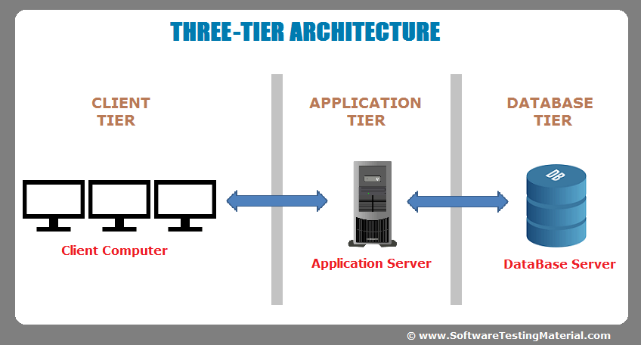

2.6 Natural Language Analysis

It is language which helps to find out the noun, verbs and adjective. There is scenario about the online food ordering system. From the scenario have to find out the noun which is repeated or not then write the only one which is useful which have same meaning. same process goes to adjective and verbs too.

|  |  |
| --- | --- |
| Nouns | verbs |
| Restaurant, place, food, order, customer, admin, delivery, place, user, name, time, user, problem, responsible, | Add, Update, Remove, review, register, login, find, details, store, notify, prepare, mention, select, confirm |

Final Candidate class noun are:

Admin, Customer, Order

Final Verbs are:

Add, Update, Login, Delete, register, item, review, confirm

2.7 Initial class diagram

It is a diagram which is the part of a UML that provides the structure of a system in terms of classes, attributes and methods.

2.8 Use case diagram

It shows the interaction between the user and system helps to manage all functional requirement. In this diagram shows the work of the individual for the system. It also registers the communication between user and system.

Chapter 3 Design

3.1 Introduction

In design stage, we talk about the diagrams and model that used in this task. We may develop many more design which can be used to the project goals and can choose the best design by the stakeholders for the project. Design plays very vital role on the project achievement. Different designs used because to understand the requirements. In this phase, database design and user interface done because to give the overview how the system backend and frontend would be like. we will build up different diagram like: class, Entity Relationship, Sequence, Activity. There are many types of design and have to do all this design to get better user requirements.

Many types of design they are explained below:

3.2 Structural Modelling

It is general answer of application to be established. It gives solution for the visibility of data and specifies memory requirement and also debugging functions. It also declares the method variable and their privacy like they are public or private.

3.2.1 Class Diagram

It is a type of diagram which is the part of Unified Modeling Language that defines the overview of a system in terms of attributes, classes, operations and many more. It also shows the relationships between different classes.

Some symbols of class diagram are:

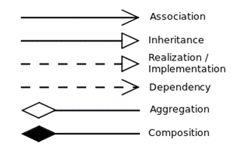

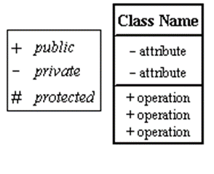

Justification

Class diagram is the important architecture diagram. In this diagram, shows the relationships between the classes. Show the connection between the classes. There are many symbols and they have many meaning of them. Class diagram shows which one is private and public.

3.2.2. Flow chart

3.3 Behavioral Modelling

It is such type of modeling which deals with the functionality of entire system. It is also known as dynamic model. It is also very useful model to the system.

3.3.1 Activity Diagram

In this diagram, shows all the steps one by one program. It also shows the program with the corresponding activities. it is used to show the work how it is doing in the system and what should be done after another.

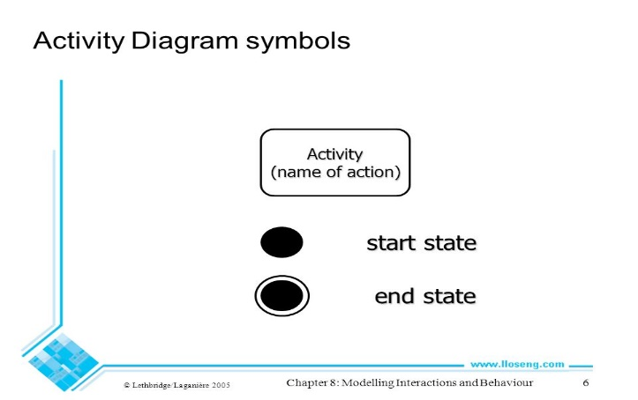

starting and ending node and action symbol

* Final flow node

See the source image

* Decision

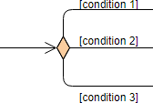

* Merge Node

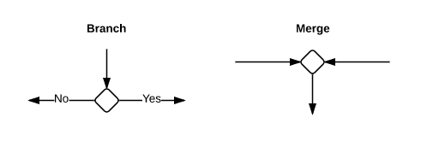

* Fork

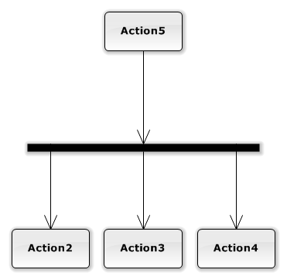

* Join

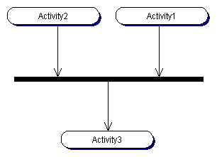

* Control flow which connect all the actions.

3.3.2 Sequence Diagram

It is used to show the objects interaction in a specified condition. This diagram starts from the near top and end at the bottom.

3.4 Database Design

It is the process of managing and placing the data in its database and used to create the database whole overall system to delete data redundancy. This will give us fast, safe and reliable database. It helps to reduce the errors, redundant the data. It is very useful diagram and also gives the developer a logic of relationships between object that helps to clean out the design of the system. It also helps to meet the requirements.

3.4.1 Data-Dictionary

It is a record of database and their relationships to be It is secure and no one can view the data so it safe. It holds all the name of data, data type, constraints, null or not null. It helps to handle the large database so it is used by developer to make free data redundancy.

The constructed databases are:

3.4.2 Entity Relationship Diagram

Diagram who shows the relationships of the unit sets kept in a database. Collection of entity set which is similar entities and have attributes that defined its properties. In entity relationship diagram defined the entities, attributes and show the relationships between them.

Key components they are:

* Entity:

It defined the object that may exists and It has own characteristics and It makes different identify from others. It can be changed from an object to person.

* Attributes:

It defines each entity and It refers database components. Examples: User ID, Username.

* Relationship:

It is also known as linking the entities all together. It shows how the entities are interrelated with each other.

Three Types of relationships they are:

* One to one relationship:

This relationship means only one attribute have one matching value to another table.

* One to many relationships:

One attributes which have many matching attributes in another table. Or can say parent record is used in many times in another table.

* Many to many relationships:

In this relationships which have many columns in the table lines to another table.

3.5 User Interface Design

Its main goal is to ensure the interface has elements that must be easy to use, access those actions. It is made basically for user usability and productivity. It is made to use by users to make them easier and user friendly.

Chapter 4 Implementation

4.1 Introduction

Coding is the main part of all design, analysis and all the diagrams made. First collect all the requirements to the system then design and many more methods at last to build the product have to come this phase that is coding phase. It is very important phase because if phase is not then our product will not able to come in the market. So, it plays a very vital role in the project.

When all the things are done then coding will start. In this stage I had choose programming languages and different framework because to make the project better. The UI design will be following all designs. To make the project easy we made many diagrams such as activity, sequences and many more. It helps to know better.

4.2Coding methodology (Language, Framework, tools, database)

For the project, I have chosen PHP core language. It is very easy to understand. It helps to build all the web application quickly. It saves our time makes our code fashioners. I have used Notepad++ and it is very easy to use even you are new to this. It is one of the simple and flexible language that allows to handle exceptions. MVC pattern is used in implementation. MVC stand for Model View Controller. If we do in MVC pattern, then it is very easy to do coding. It divides the works in their patterns. I have also used java Script HTML5 and CSS and also bootstrap for the bar and many more.

For webserver I had chosen XAMPP. It is free open source. It is very easy to download and makes the work easily. No need to server for this. Just you have to start apache and MySQL. I had chosen this server because it also works even without internet it has own server. That’s why it is very important for everyone who is making any project. It is impossible without XAMPP. So, it plays a vital role in the project.

For database I have used MySQL. It also plays very vital role for the project. It connects all the database. If there is no connection, then project is incomplete without it. we must have the connection between them. To keep all the data, I had used phpmyadmin. It stores all the data. It is also important for the project.

4.3 User Manual

It is guide which to give the direction to use this application. This is e-commerce website. In this website there are view part which means home page of website. There is login button for the customer. you have to click that login in button. If you have already email account, then you do not have to make any new account if you are new to this website then you must have to register first. you can see the food items over there and there is order now button just you have to click that and confirm that food. And also you can buy again if you want and you can add your quantity. If you want to delete your order, then you can delete your order too.

Chapter 5 Testing

5.1 Introduction

Testing is also one of the stage after implementation. And it also very important in every projects. Testing helps to find out mistake and free from bug. It develops user-friendly in the system. In this stage we may know the about our projects and many more. Testing means to checking the own project, rate to the quality and functionality. It helps to check the quality of code and many more.

There are many testing some of them are given below:

* Black box testing:
* White box testing:
* Unit testing:
* Usability testing:
* Integration testing:

Among these all testing I had chosen Black box and Unit testing.

5.2 Black box testing

It is testing technique in which functionality tested without looking internal code structure.

Some tests are:

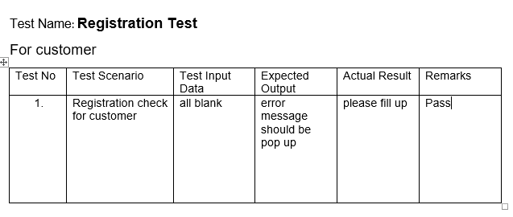

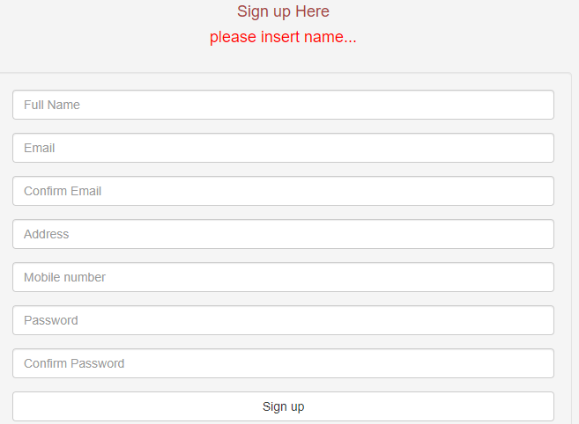

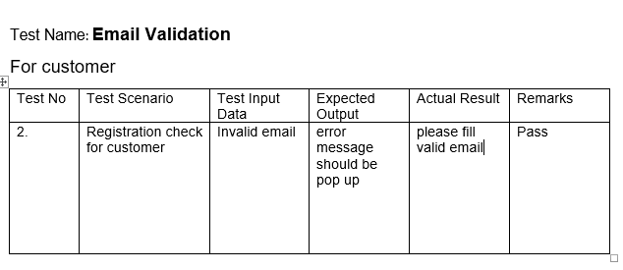

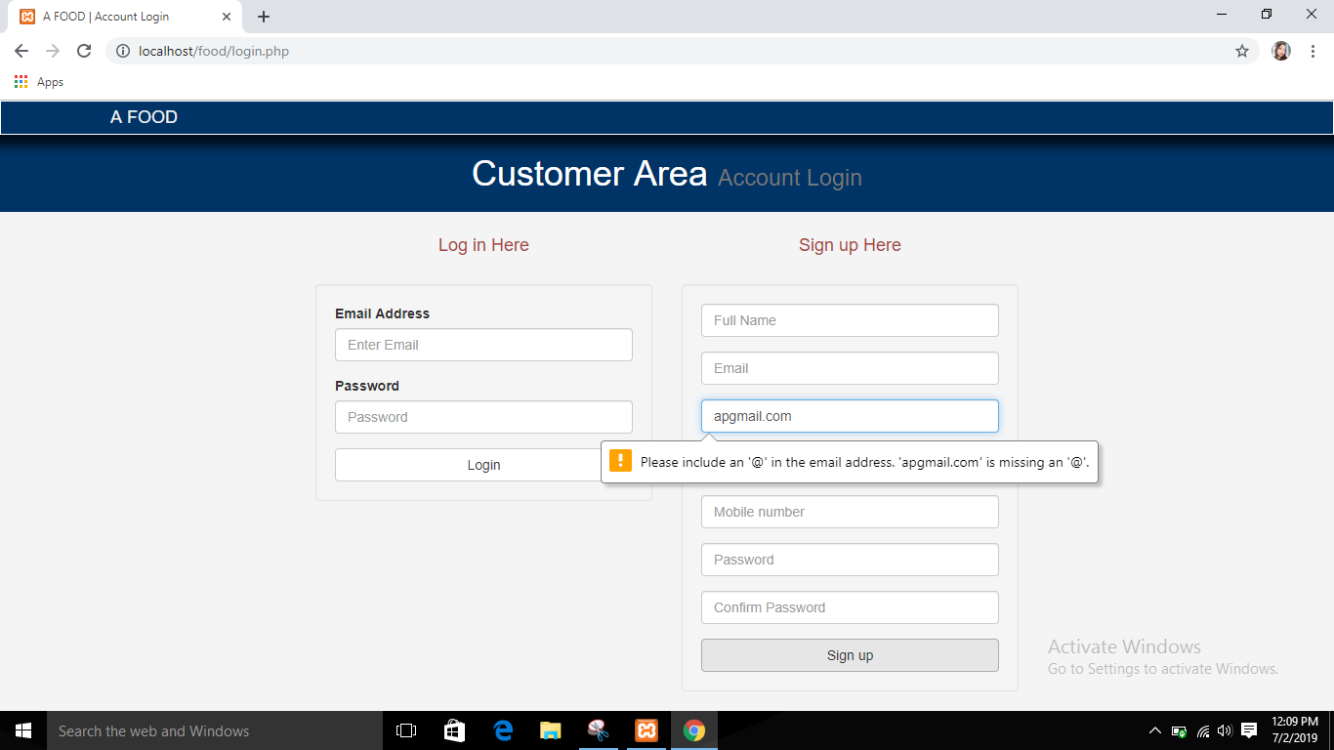

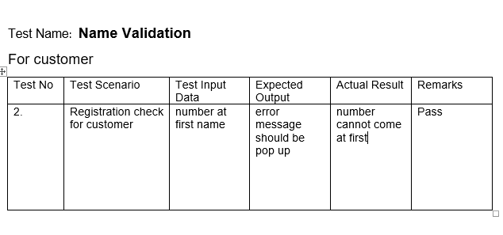

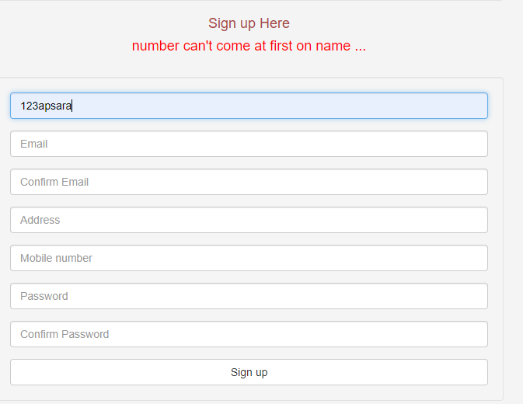

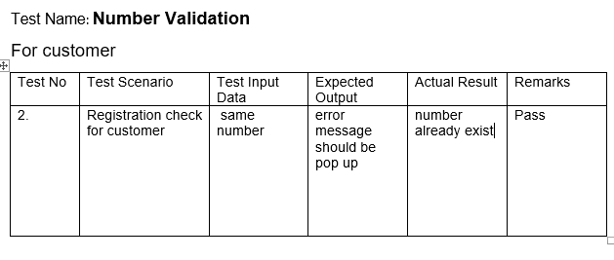

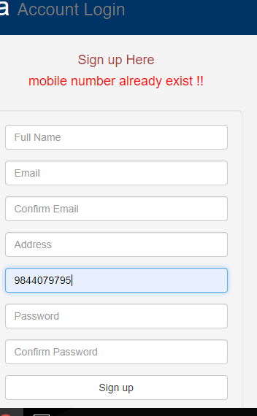

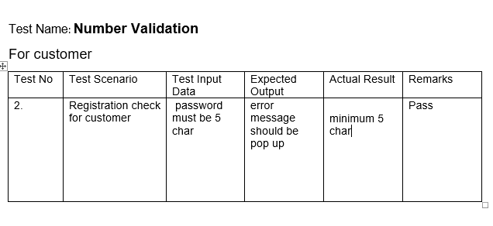

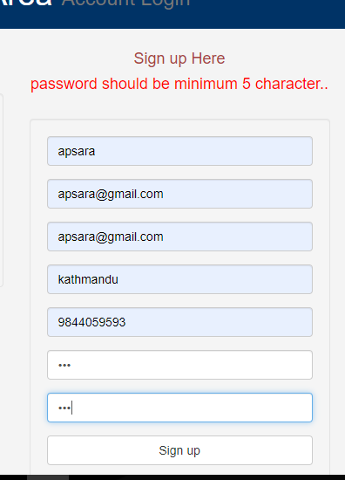

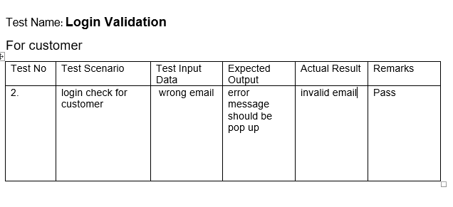

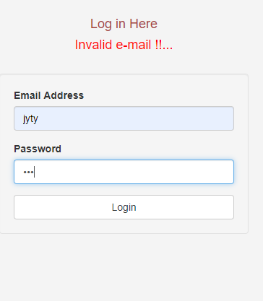

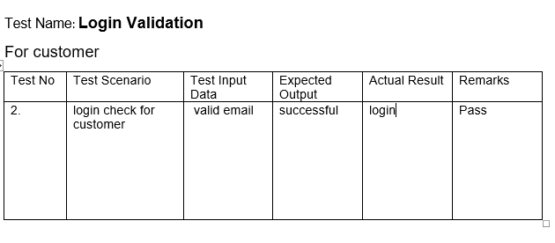

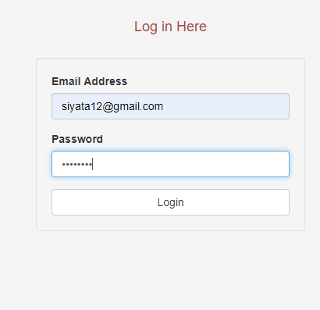

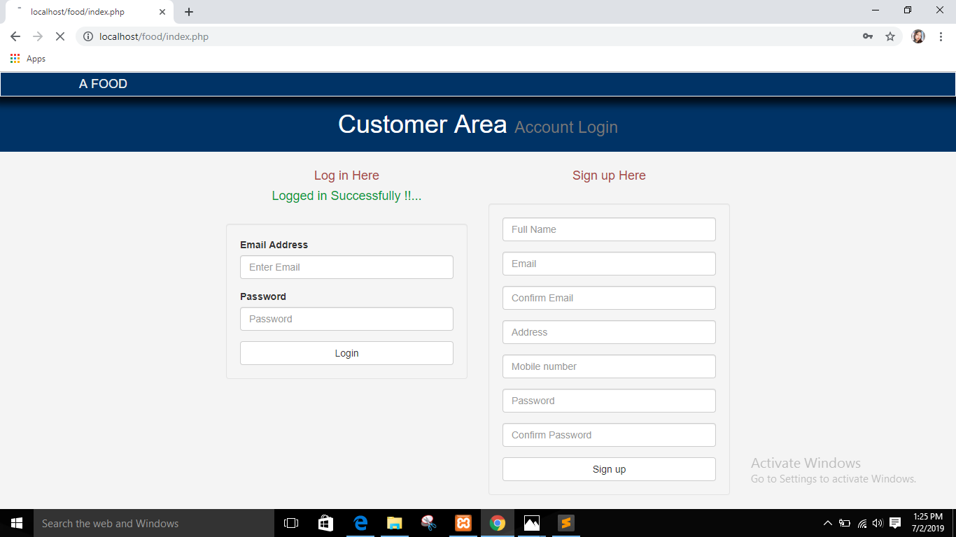

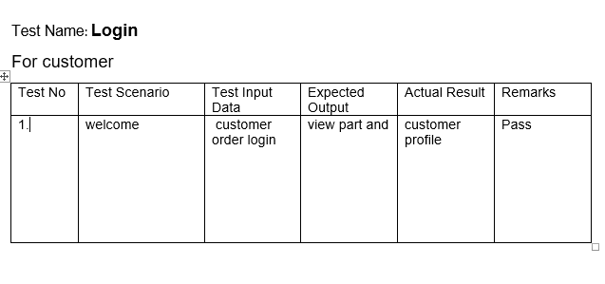

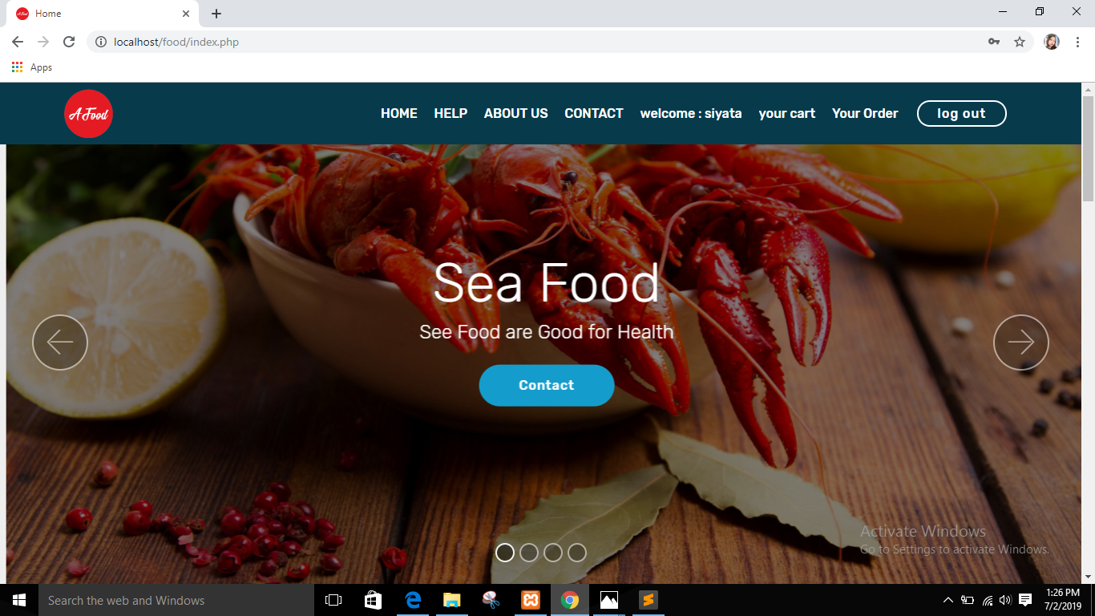

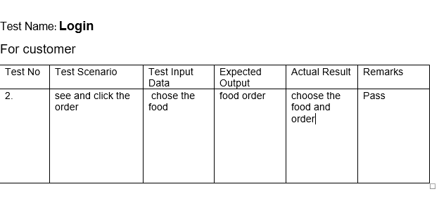

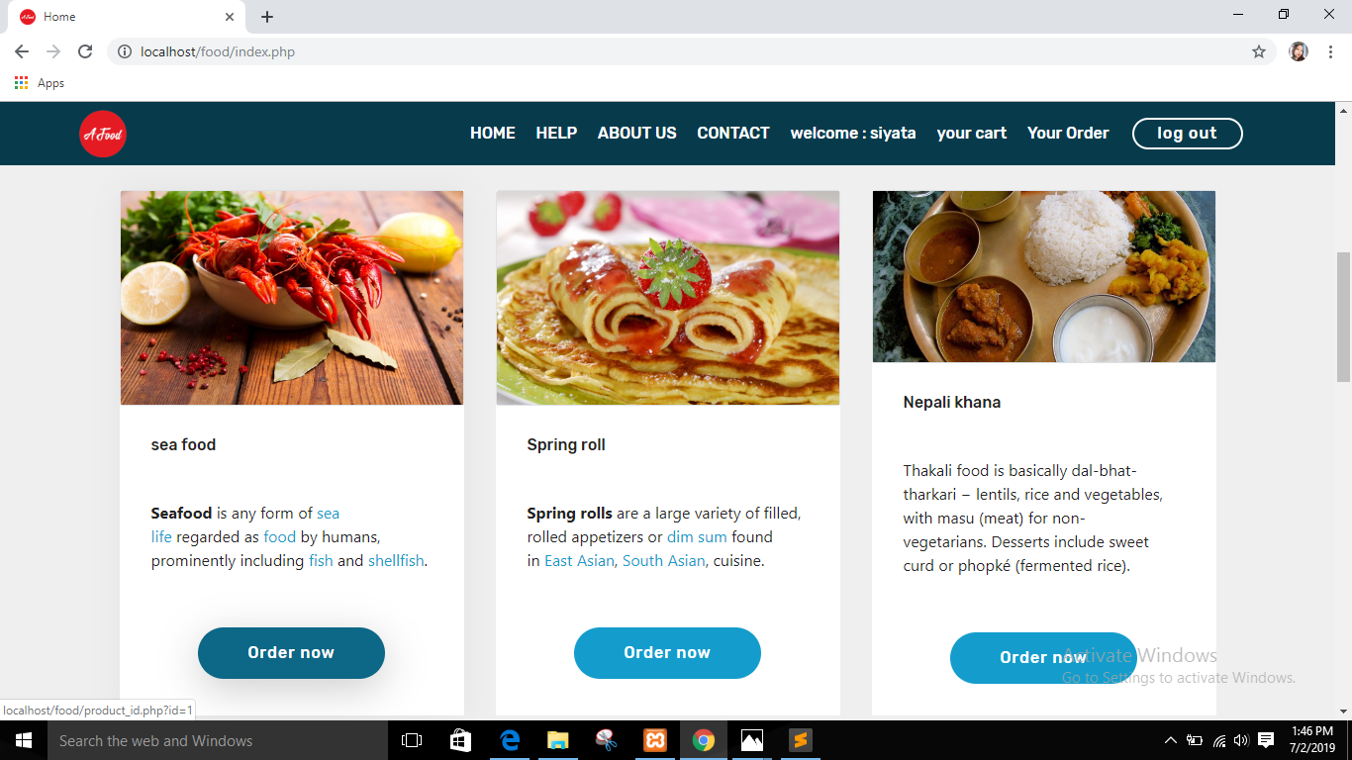

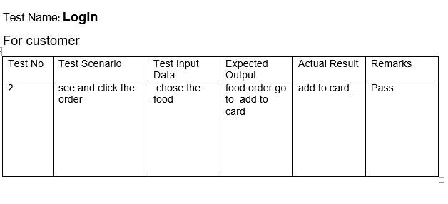

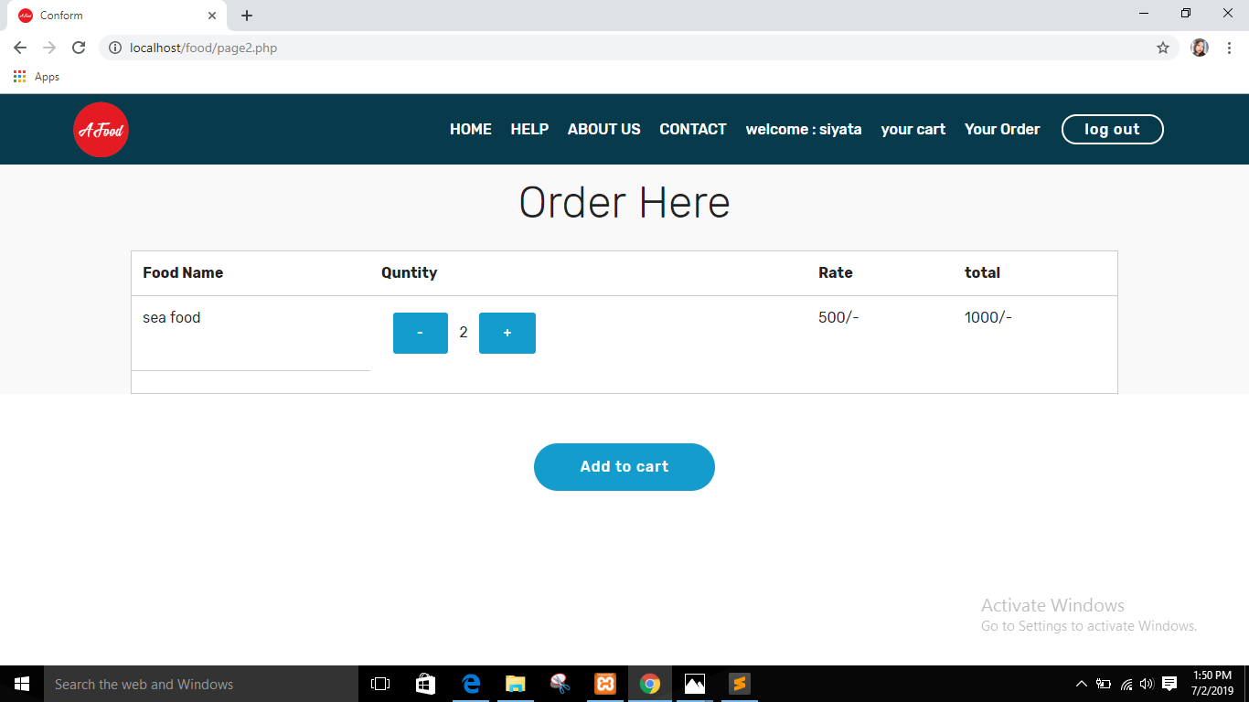

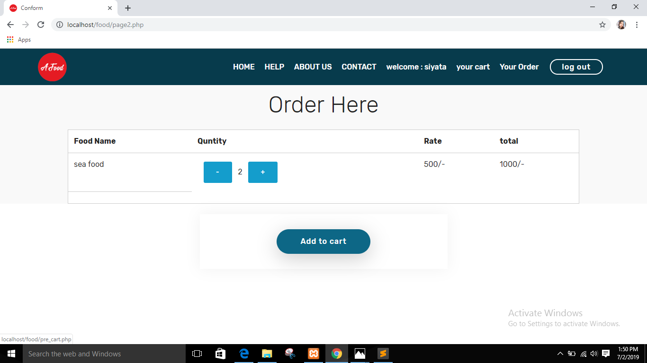

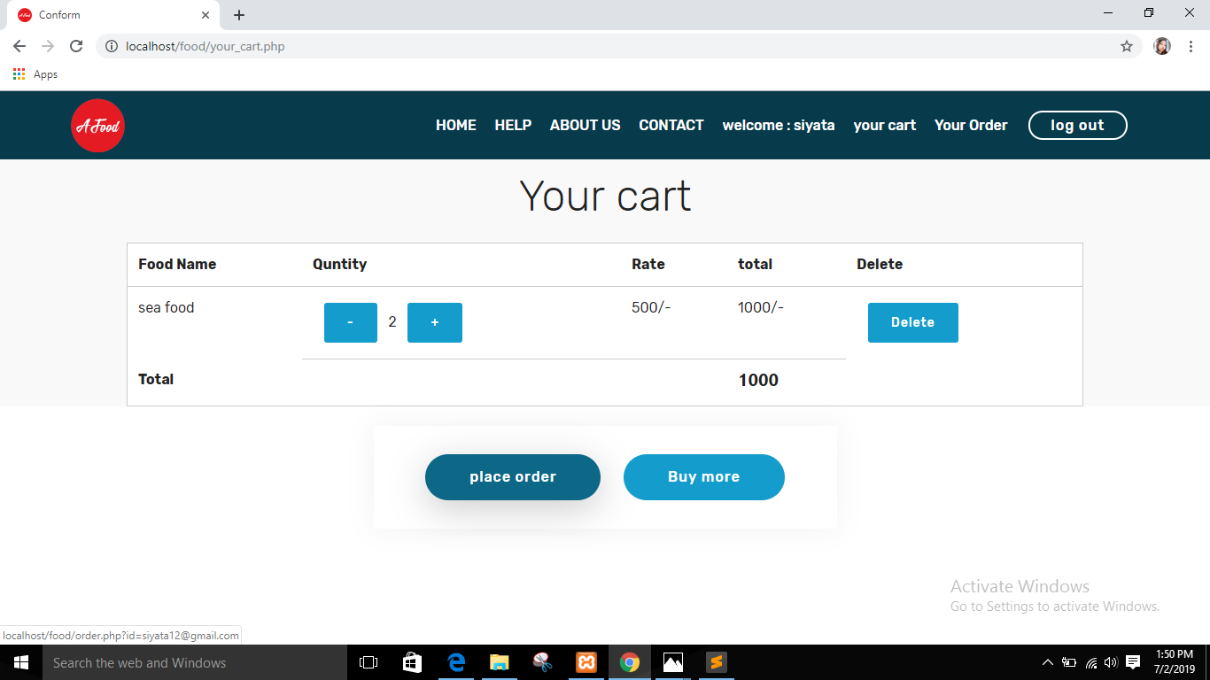

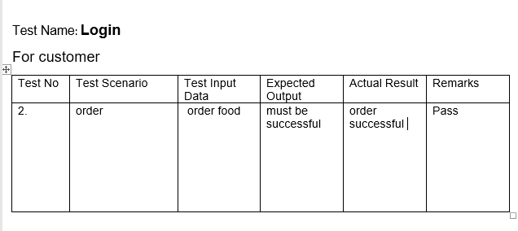

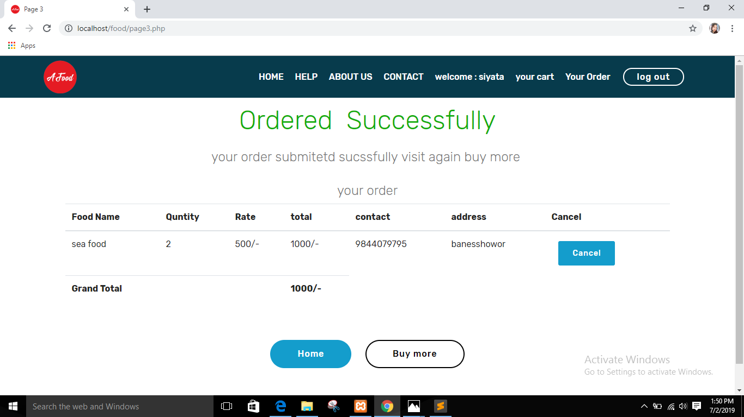

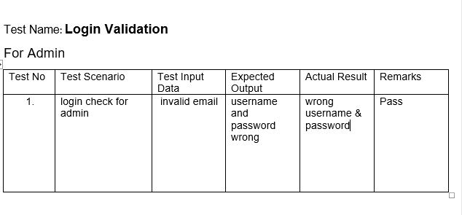

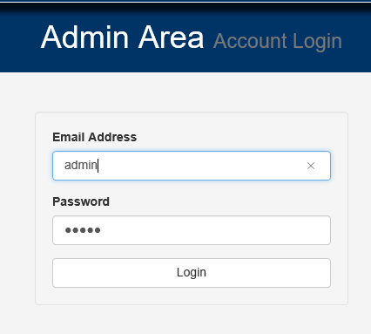

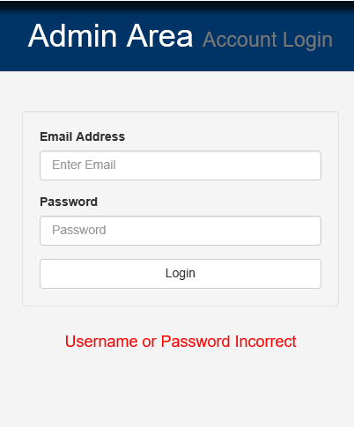

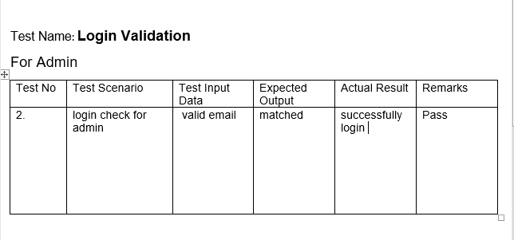

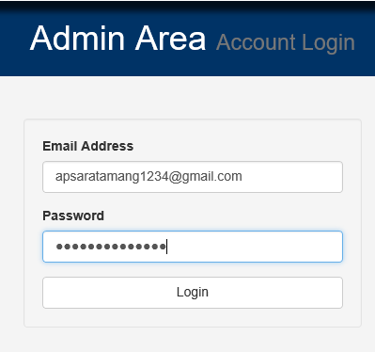

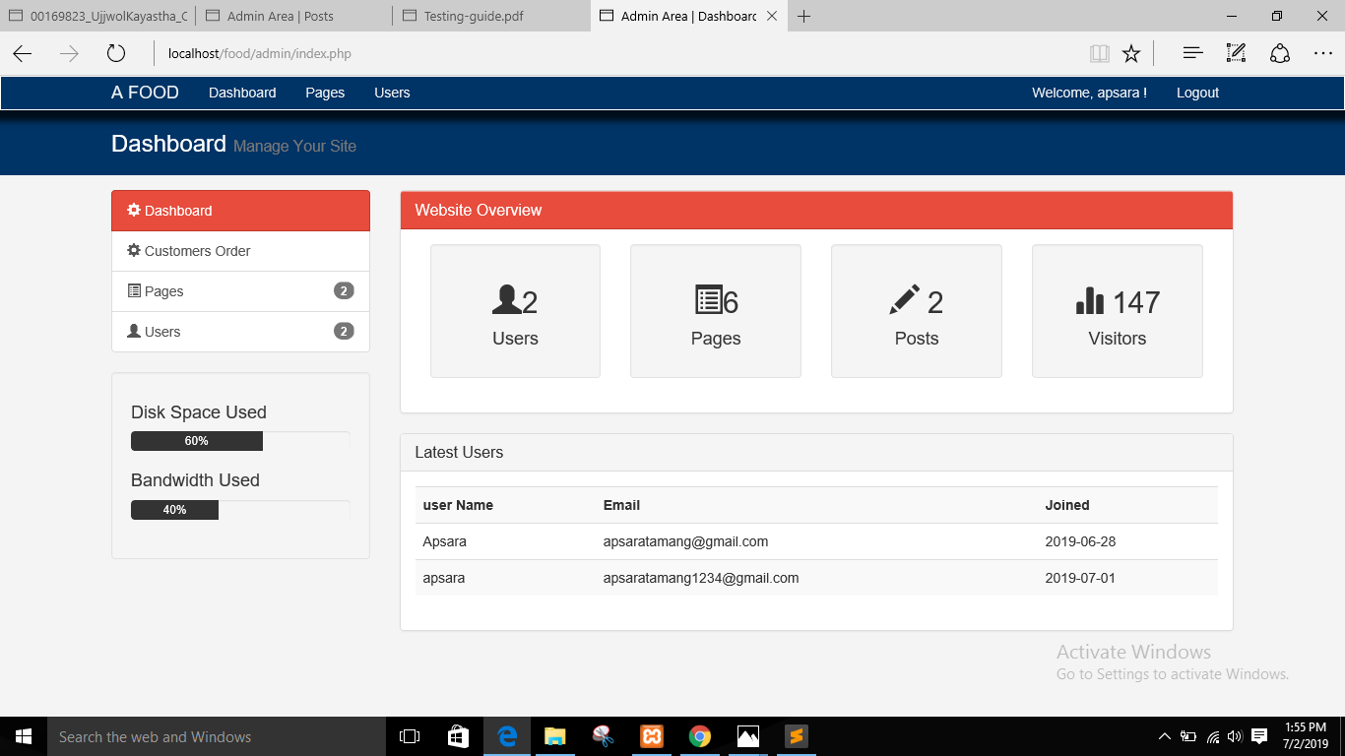

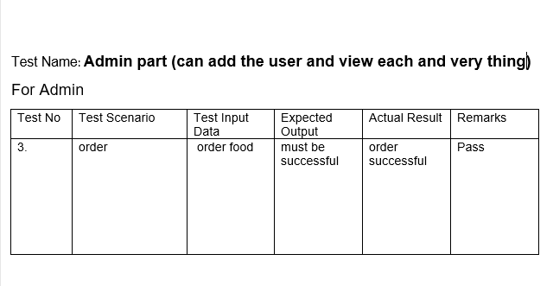

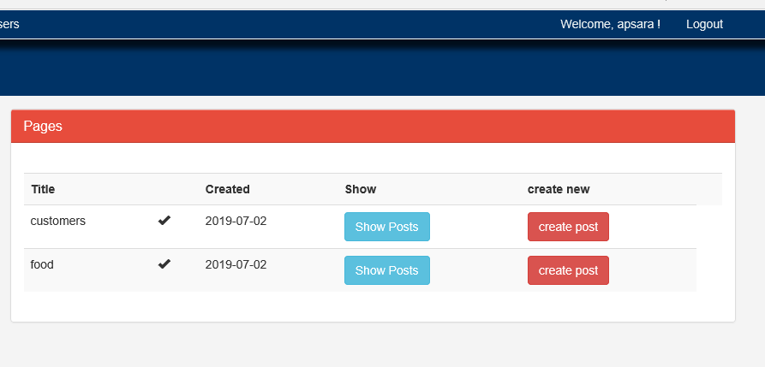

5.3 Unit testing:

unit testing is a software testing method by which individual units of source code,

Chapter 6 Other Project issues

During developing this project many difficulties arrives but I solved all the problems and made my project successfully. From starting of the requirements to designing to implementing, testing and final many obstacles arrive. But I gave my best to solve all the problems. Many issues came during the project just like login issue, database issue and many more.

6.1 Risk Management

It identifies the risk and analyzed risk factor in the project. It is also one of the part of this process. It helps to figure out the problems and risks in upcoming future.

**Some possible risks:**

* Managing the products
* Wrong delivery
* Time consuming
* Server failure
* lack of skill

**Impact = Likelihood * Consequence**

**Risk likelihood table**

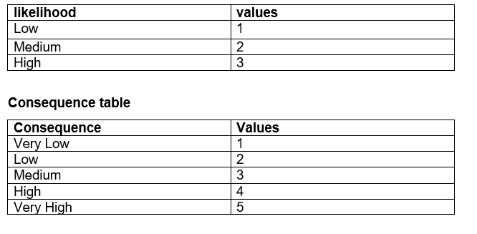

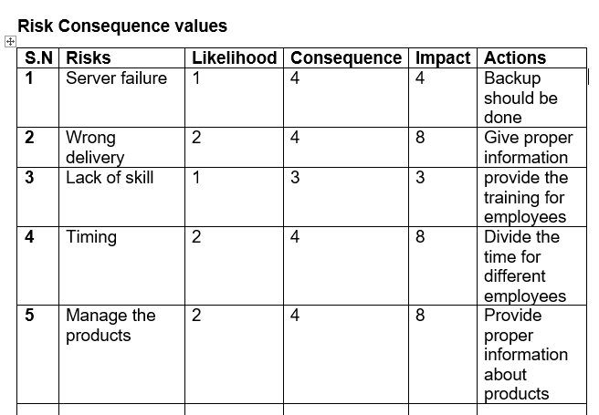

6.2 Configuration management

6.3 Scheduling

6.4 Future Work

6.5 User manual

6.6 Limitation

Chapter 7 Conclusion